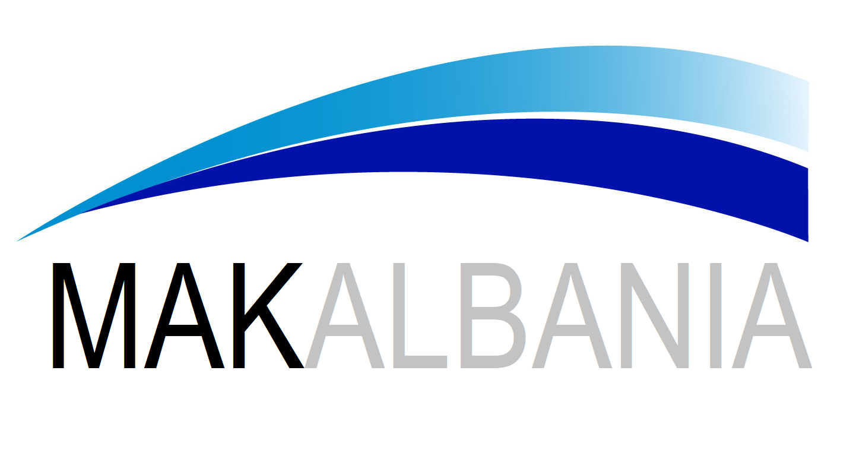
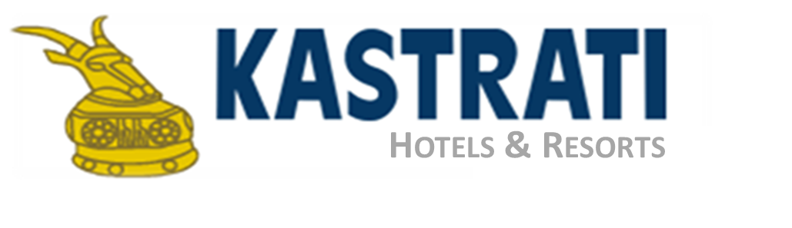

MAK Albania Hotel
Hotel Reservation form
"EBEEC Conference – 15 – 18 MAY 2025

In order to book a room at MAK Albania Hotel, Tirana, Albania for the above mentioned event, you are kindly asked to contact the hotel reservation department at the email address: reservations.tirana@makalbania.com

Family name: ____________________________ First name: _____________________________

Tel: ______________________ Fax: _______________ Email: _________________________________

Arrival date: __________________________ Departure date: _________________________________

Total nights: __________________________ Arrival time in the hotel: (approx.) __________________

For reservations from January 15th – February 15th:
Accommodation in standard room (single occupancy) – 10 500 Leke/night
Accommodation in suite (single occupancy) – 14 500 Leke/night

For reservations from February 16th – March 15th:
Accommodation in standard room (single occupancy) – 11 500 Leke/night
Accommodation in suite (single occupancy) – 15 500 Leke/night

All prices are inclusive of breakfast and all local taxes.
Additional tariff for double occupancy is 2 000 Leke/night

*tariffs given are in leke Albanian Leke/Currency

Please indicate method of payment and guarantee reservation with credit card details:

Credit card no: _________________________________ Expiry Date_____________ CVC _

Credit card name: _____________________________ Signature: ______________________________

*Credit Card accepted from the hotel: Visa Card, Master Card and American Express.

Deadline for accepting hotel reservation is March 15th, 2025
After this date any request will be upon hotel standard prices and availability

Early Check-in (subject to availability)

Usual fee of 5 euro/hour.

Late Check-out (subject to availability)

Usual fee of 5 euro/hour.

Kastrati Hotels & Towers
Sheshi Italia, Tirana - Albania
T: +355 (04) 227 4707 | F: +355 (04) 227 4711
http://makalbania.com

